IOE AND AI DRIVEN SYSTEMS
LAB OUTPUTS
NAME:N.SHANMUKA PRIYA
REG. NO.:192512075

EXPERIMENT 4:
PROGRAM CODE:
import numpy as np
import pandas as pd
import matplotlib.pyplot as plt
# IoE PROTOCOL PERFORMANCE COMPARISON
np.random.seed(24)
protocols = ["Zigbee", "6LoWPAN", "NB-IoT"]
simulation_time = 120 # seconds
packets_sent = 1200
packet_size = 512 # bytes
# Illustrative baseline values (NOT NS-3 measurements)
parameters = {
"Zigbee": {"pdr": 92, "delay": 38, "energy": 15, "throughput": 41},
"6LoWPAN": {"pdr": 89, "delay": 62, "energy": 21, "throughput": 34},
"NB-IoT": {"pdr": 97, "delay": 72, "energy": 29, "throughput": 45}
}
results = []
for protocol in protocols:
p = parameters[protocol]
# Illustrative variations for demonstration only
pdr = np.clip(p["pdr"] + np.random.normal(0, 1.0), 0, 100)
delay = max(0.1, p["delay"] + np.random.normal(0, 2.5))
energy = max(0.1, p["energy"] + np.random.normal(0, 0.8))
throughput = max(0.1, p["throughput"] + np.random.normal(0, 1.2))
packets_received = round(packets_sent * pdr / 100)
results.append([
protocol,
packets_sent,
packets_received,
round(pdr, 2),
round(throughput, 2),
round(delay, 2),
round(energy, 2)
])
df = pd.DataFrame(results, columns=[
"Protocol",
"Packets Sent",
"Packets Received",
"Packet Delivery Ratio (%)",
"Throughput (kbps)",
"Average Delay (ms)",
"Energy Consumption (J)"
])
# DISPLAY RESULTS
print("=" * 85)
print("IoE COMMUNICATION PROTOCOL PERFORMANCE ANALYSIS")
print("=" * 85)
print("Simulation duration:", simulation_time, "seconds")
print("Packet size:", packet_size, "bytes")
print("Data status: ILLUSTRATIVE EXAMPLE — NOT NS-3 OUTPUT")
print()
print(df.to_string(index=False))
# PERFORMANCE SUMMARY
best_pdr = df.loc[
df["Packet Delivery Ratio (%)"].idxmax(), "Protocol"
]
best_throughput = df.loc[
df["Throughput (kbps)"].idxmax(), "Protocol"
]
lowest_delay = df.loc[
df["Average Delay (ms)"].idxmin(), "Protocol"
]
lowest_energy = df.loc[
df["Energy Consumption (J)"].idxmin(), "Protocol"
]
print("\n" + "=" * 55)
print("PERFORMANCE SUMMARY")
print("=" * 55)
print("Highest packet delivery ratio :", best_pdr)
print("Highest throughput :", best_throughput)
print("Lowest average delay :", lowest_delay)
print("Lowest energy consumption :", lowest_energy)
# INDIVIDUAL PERFORMANCE GRAPHS
metrics = [
("Throughput (kbps)", "Throughput Comparison", "Throughput (kbps)"),
("Average Delay (ms)", "Average Delay Comparison", "Delay (ms)"),
("Packet Delivery Ratio (%)", "Packet Delivery Ratio Comparison", "PDR (%)"),
("Energy Consumption (J)", "Energy Consumption Comparison", "Energy (J)")
]
for column, title, ylabel in metrics:
plt.figure(figsize=(8, 5))
bars = plt.bar(df["Protocol"], df[column])
plt.title(title)
plt.xlabel("Communication Protocol")
plt.ylabel(ylabel)
plt.grid(axis="y", alpha=0.3)
if column == "Packet Delivery Ratio (%)":
plt.ylim(0, 100)
plt.bar_label(bars, fmt="%.2f", padding=3)
plt.tight_layout()
plt.show()
# COMBINED NORMALIZED COMPARISON GRAPH
normalized = pd.DataFrame()
normalized["Protocol"] = df["Protocol"]
higher_is_better = [
"Packet Delivery Ratio (%)",
"Throughput (kbps)"
]
lower_is_better = [
"Average Delay (ms)",
"Energy Consumption (J)"
]
for col in higher_is_better:
min_val, max_val = df[col].min(), df[col].max()
normalized[col] = (
(df[col] - min_val) / (max_val - min_val)
if max_val != min_val else 1.0
)
for col in lower_is_better:
min_val, max_val = df[col].min(), df[col].max()
normalized[col] = (
(max_val - df[col]) / (max_val - min_val)
if max_val != min_val else 1.0
)
normalized = normalized.rename(columns={
"Packet Delivery Ratio (%)": "PDR",
"Throughput (kbps)": "Throughput",
"Average Delay (ms)": "Delay efficiency",
"Energy Consumption (J)": "Energy efficiency"
})
normalized.set_index("Protocol").plot(
kind="bar", figsize=(10, 6), ylim=(0, 1.15)
)
plt.title("Normalized Comparative Performance of IoE Protocols")
plt.xlabel("Communication Protocol")
plt.ylabel("Normalized score (higher is better)")
plt.grid(axis="y", alpha=0.3)
plt.xticks(rotation=0)
plt.tight_layout()
plt.show()
# SAVE RESULTS
df.to_csv("/content/IoE_protocol_results.csv", index=False)
normalized.to_csv("/content/IoE_normalized_results.csv", index=False)

print("\nCSV files saved:")
print("/content/IoE_protocol_results.csv")
print("/content/IoE_normalized_results.csv")
# CONCLUSION FROM ILLUSTRATIVE DATA
print("\n" + "=" * 55)
print("CONCLUSION")
print("=" * 55)
print(f"{best_pdr} has the highest illustrative PDR.")
print(f"{best_throughput} has the highest illustrative throughput.")
print(f"{lowest_delay} has the lowest illustrative delay.")
print(f"{lowest_energy} has the lowest illustrative energy consumption.")
print("\nThese findings apply only to the example values.")
print("Replace them with validated measurements before reporting.")

OUTPUT:
IoE COMMUNICATION PROTOCOL PERFORMANCE ANALYSIS
Simulation duration: 120 seconds
Packet size: 512 bytes
Data status: ILLUSTRATIVE EXAMPLE — NOT NS-3 OUTPUT

Protocol Packets Sent Packets Received Packet Delivery Ratio (%) Throughput (kbps) Average Delay (ms) Energy Consumption (J)
Zigbee 1200 1120 93.33 39.81 36.07 14.75
6LoWPAN 1200 1055 87.93 34.35 58.40 21.45
NB-IoT 1200 1144 95.37 47.27 72.55 29.54

PERFORMANCE SUMMARY

Highest packet delivery ratio : NB-IoT
Highest throughput : NB-IoT
Lowest average delay : Zigbee
Lowest energy consumption : Zigbee
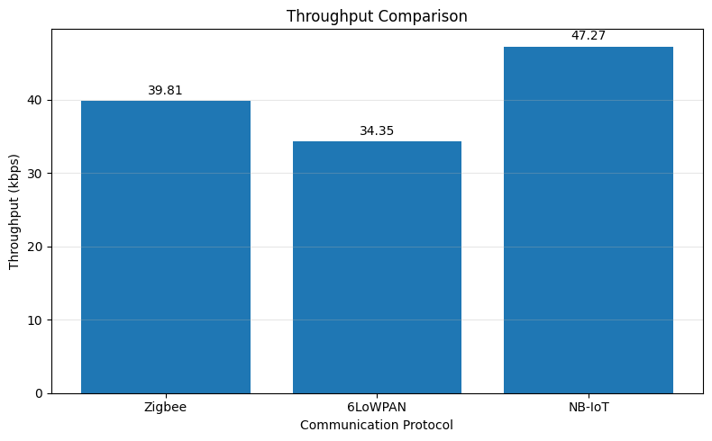
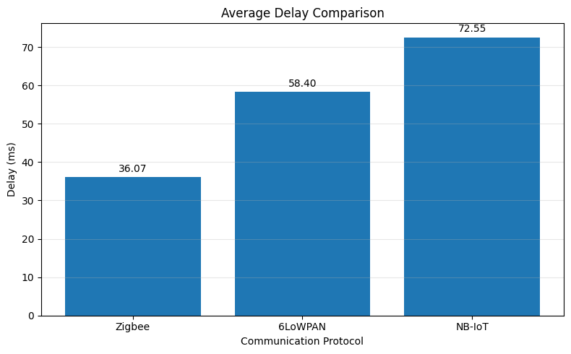
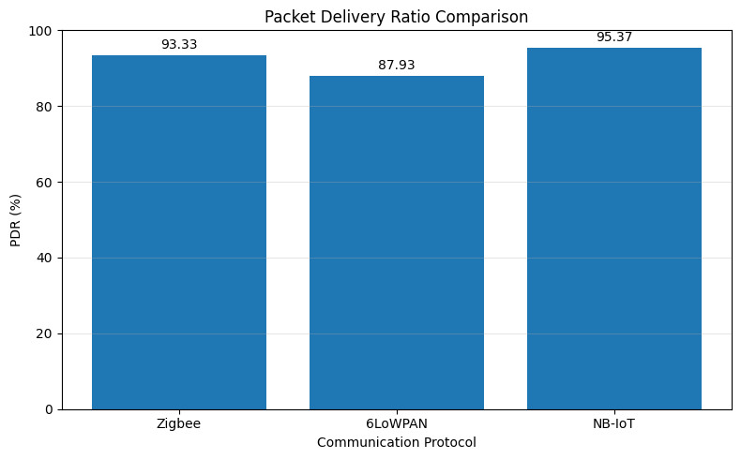
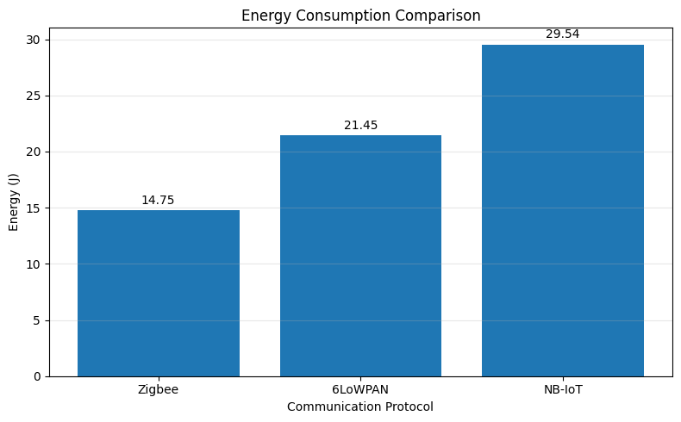
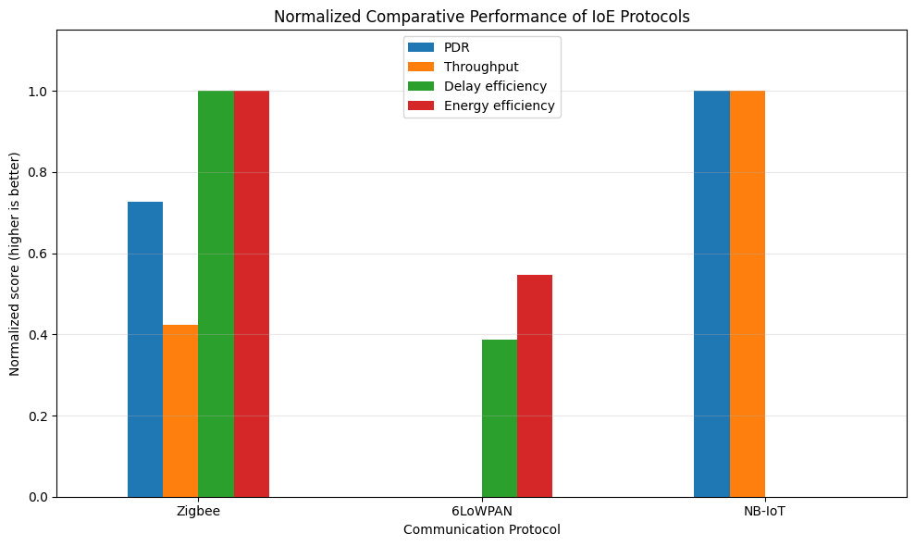

CSV files saved:
/content/IoE_protocol_results.csv
/content/IoE_normalized_results.csv

=======================================================
CONCLUSION
=======================================================
NB-IoT has the highest illustrative PDR.
NB-IoT has the highest illustrative throughput.
Zigbee has the lowest illustrative delay.
Zigbee has the lowest illustrative energy consumption.

